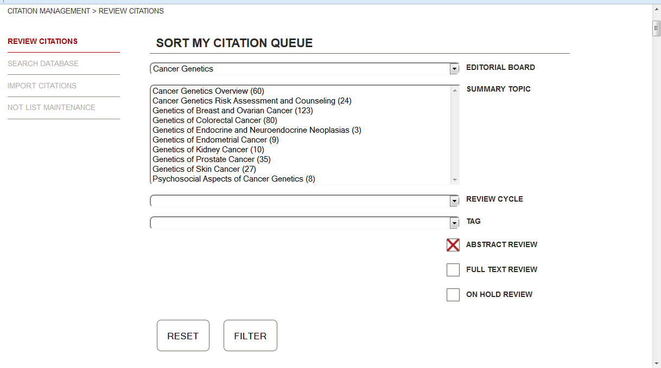
Keep EDITORIAL BOARD field but only display appropriate Board(s). Require that one Board be selected.
Keep SUMMARY TOPIC field and numbers in parentheses. Show only the topics that the Board member is currently assigned to review.
Allow selection of >1 topic.
Remove REVIEW CYCLE and replace with date fields for DATE ASSIGNED
Remove Tag field and checkboxes for various queues
Add field for PACKET NAME (drop-down menu). Default shows all. Allow selection of one packet at a time.

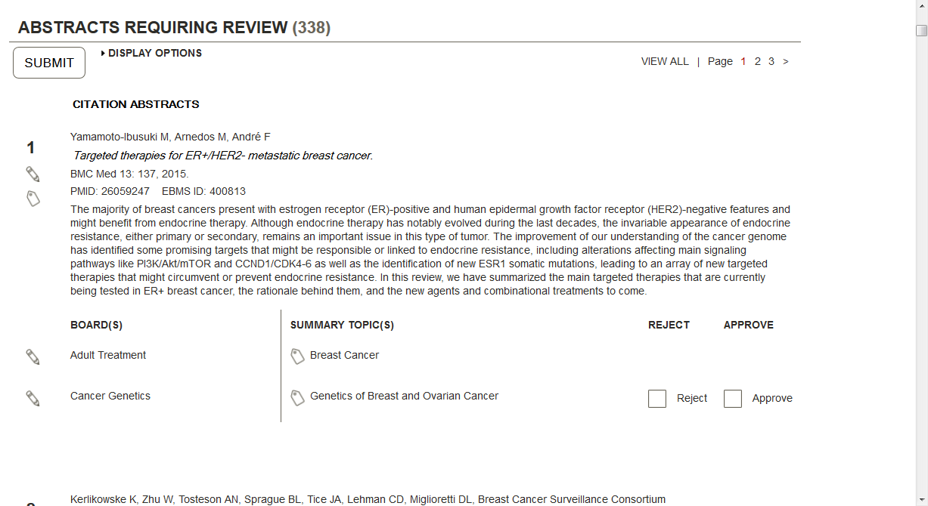
Remove BOARD(S) since we have requirement that one be selected above.
Move SUMMARY TOPIC(S) over to left margin and add options for: No Change, Add Citation, Revise Text, and Discuss. Tool tip could display the full response – e.g., “Warrants no changes in the summary”.
Could there be expandable fields added on the fly for comments, LOEs, and exclusion criteria?
Consider alternative that would allow them to quickly remove the “no’s” and then go to current review page for each “yes” to add comments/LOEs and submit one by one.
Need to figure out what to do with summaries – which to post.
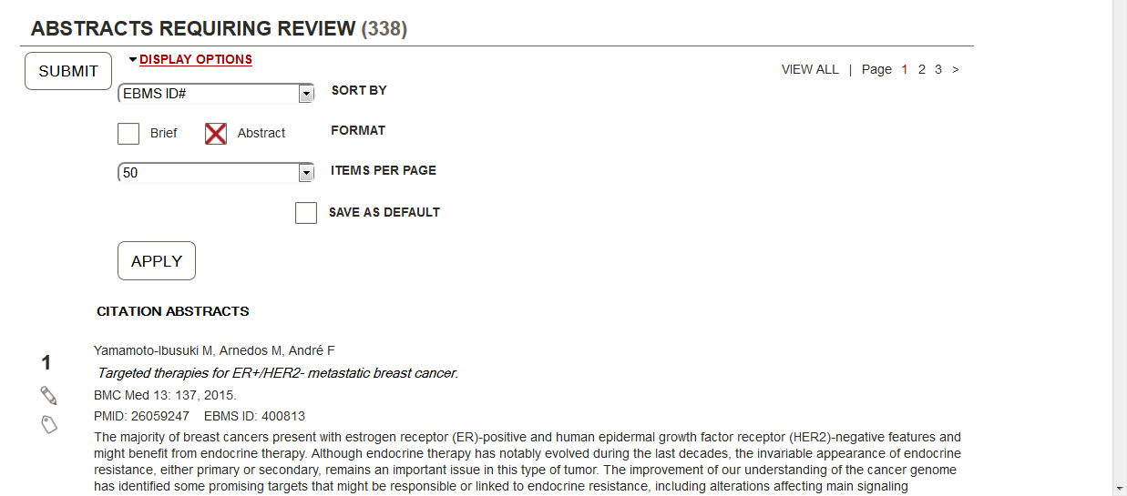
DISPLAY OPTIONS
Remove Brief format option.

OTHER ITEMS FOR DISCUSSION-
Sort articles by journal.
Should “Streamlined Queue” replace existing Assigned Packets page or be another option? Need to see what work is involved from developer perspective. Seems like it could be difficult to have two separate literature review pages for Board members.
Need to determine how to show “Other Reviews”

